Correspondence and Integrations A-1 Minutes
2.11.2026 |  | 10:00AM – 11:00AM CST
Team | Service Cloud Team
Facilitators | Mohanta Das, Jose Diaz
Note taker | Taylor Ilov
Attendees
Notes:
OPEN TEXT
Notes about Factsheet Problems for Correspondence and Integrations (Day before workshop)
Need to re review Factsheet —> Dawn thinks if we have the factsheet in future state, then they won’t learn the new functionality of the system
Thought that open text viewing invoice is the only thing that is archiving - need to confirm the objects from technical team that is also archiving
Function module in CRM for getting data from Factsheet name used to get the information from ECC (Implicit enhancement)
Function model in ECC to display information from the Factsheet
Past Due, Current, Balance fields —> if we use standard S/4 calculations there may be a problem since in ECC there is a custom Zfield doing calculations in the backend for this
Caploans (in FPL9 but not on Factsheet)

~~~~~~~~~~~~~~~~~~~~~~~~~~~~~~~~~~~~~~~~~~~~~~~~~~~~~~~~~~~~~~~~~~~~~
Open Text / Factsheet Fields- Options
- If Archiving is the only need for Open text, we could potentially link directly to Open Text
- Action: Tarah identifying what are critical fields for the Factsheet - add action item
(Payment History, Billing History, Pinging Meter)-all covered à check teams Chat
Complaints - billing history, premise history (insert screenshot from Ajay of Z fields)
(Need to determine if we have the NOT covered fields in one of our planned WRICEFS
From Stacey Nowak:
One requirement is we need to be able to see invoices for gas/elec ISU billing separate from SD construction invoices, damage claim invoices, etc.
- Fiori app and mash up directly in S/4 – requires heavier customization
~~~~~~~~~~~~~~~~~~~~~~~~~~~~~~~~~~~~~~~~~~~~~~~~~~~~~~~~~~~~~~~~~~~~~
ISIS only shows 18 months’ worth of Data
(Mash up regardless, but then may have to create a Fiori app on top of that)

From Jeanne:
Archiving: From a billing rule standpoint, if the customer is overbilled, we have a requirement to correct the account 3 years immediately preceding the error. The invoice is used to calculate interest; currently we pull an invoice from the back office; via ISIS...\

Stephanie’s team also only uses back office

(Billing history – goes back 3 years.)

Zach’s team- will do bill reversals and rebills in Front office

Dawn has an account that has been moved in for 20 years and it’s only showing 2 years of history. We need to look more into this.
Who needs to see these really old archived documents?

Natalie uses itemized statement to search fields too

What are we going to do with the Data in Open Text?
View into open text docs, is this integration realy needed.
Tarah has the meeting on Friday with CSRs to check into Fact Sheet, we will go from there to move forward with this decision

On the fact sheet if they have an outstanding balance in top right corner
Only way you can see the balance is by pulling the archived data from Open Text.

Invoices are archived
Open Balance are not archived

Balance, service dates, address, then drive down to collections, agency, etc. (Jose thinks all of these areas are standard in Service Cloud)

We will use existing WRICEFs to cover where these fields are being moved to à so factsheet will not exist in future state

Change Impact à CSRs will not be navigating the Factsheet to access things like Balance, service dates, address, then drive down to collections, agency,à we will instead be finding different homes for these fields

Decision: Determining what fields are critical to keep from the factsheet and where we can standardize these in Service Cloud V2

From Ajay: (Do we need them to see this in front office), need to check on usage of this in back office
Billing has a different view of the Factsheet
Billing History tab used frequently à in SCV2
Invoices older than 3 yrs – not used often
Natalie going to itemized statement for other financial info
Business center has a lot of rebills – going back 1 yr, meter may not have happened for 2-3 years, using 3rd year to determine the usage of that meter for customer.

Move In hard stop gives a shorter list of info, when you need to drill down they go to the Factsheet for this additional info. Harder for newer CSRs to use Itemized Statement.
CSRs will back out of Move in to go to Factsheet for this information

Decision: Removing the Customer Account Factsheet + Finding new spots for critical fields in Service Cloud
This will essentially save time for CSRs, not having to take the the time halfway in Move In to go back and get information about the account so in Service Cloud this it will optimize their process to not have to open a second session but instead have the move in started and then look up the contact account to get the info they need without backing up out of the move in process
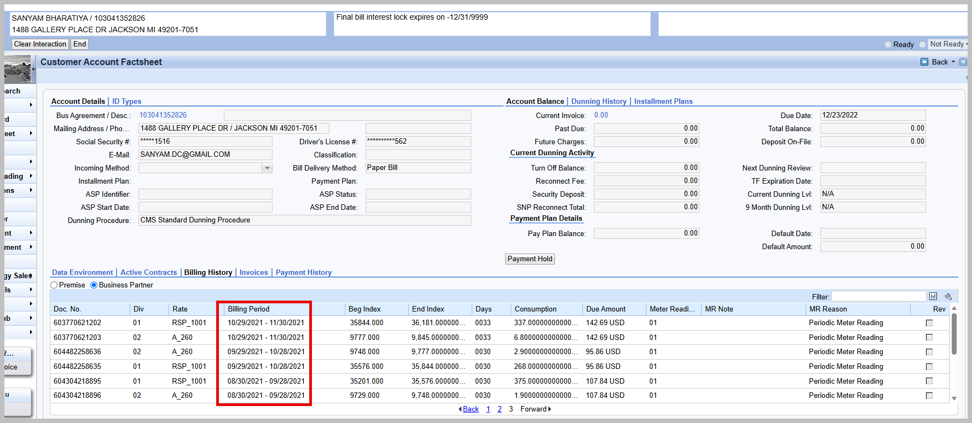
~~~~~~~~~~~~~~~~~~~~~~~~~~~~~~~~~~~~~~~~~~~~~~~~~~~~~~~~~~~~~~~~~~~~~~~~~~~~~
AGENT INBOX
Agent inbox will be in Fiori, Mashup is not needed
(Park docs, refund approvals) SO01 TCode in Backoffice
Standard T Codes are turning into Fiori apps unless you are removing the roles
Security workshops running separately, Dawn confirming that this is not removed by security teams
~~~~~~~~~~~~~~~~~~~~~~~~~~~~~~~~~~~~~~~~~~~~~~~~~~~~~~~~~~~~~~~~~~~~~~~~~~~~~
RIVERSTAR
Multiple correspondence avenues, system is launching for agents to send to Customers. This is inclusive of the email program.

Forms Menu – only email and paper
Riverstar – text and email

Can do email blasts from Service Cloud, but we need the texting from Riverstar
Maybe 20 different forms in Riverstar
Texting link to a form, account
Billing uses it for letters
Manual step to do this
(Example installment plan, never required, heavily encouraged, à sending copy of installment plan to customer.
FACTA letters have the requirement to send Forms via riverstar
Decision: have button in multiple areas to access Riverstar à will determine what screens will have this button during design
KEEPING RIVERSTAR – simple integration

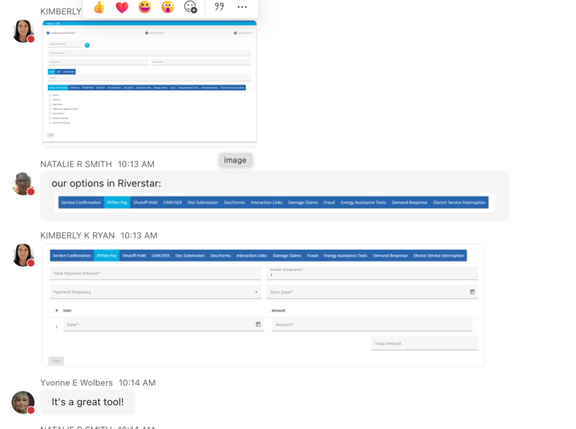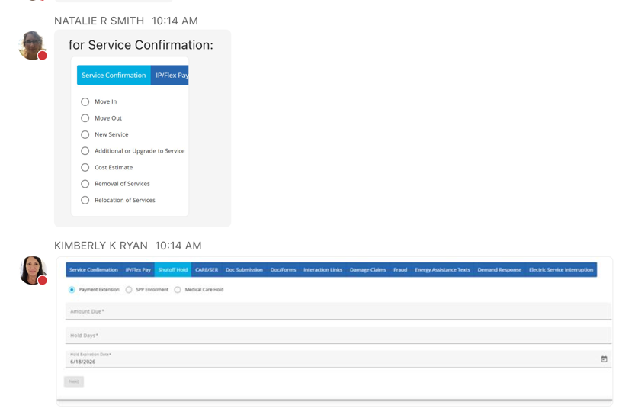

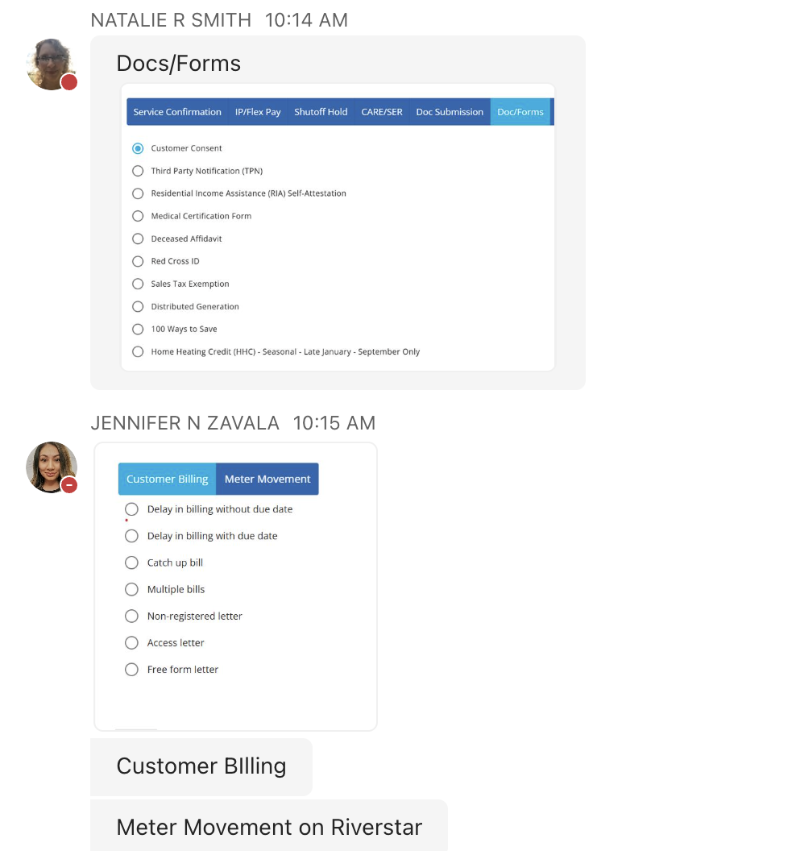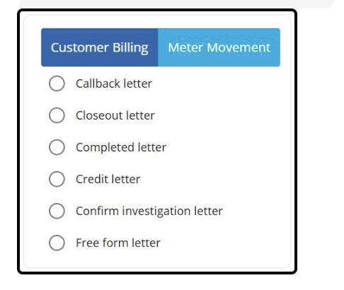
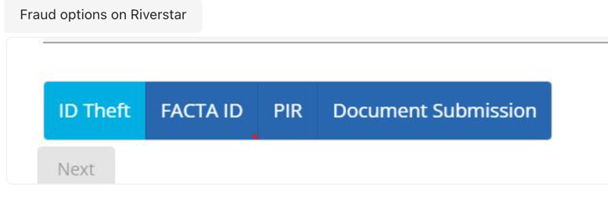

~~~~~~~~~~~~~~~~~~~~~~~~~~~~~~~~~~~~~~~~~~~~~~~~~~~~~~~~~~~~~~~~~~~~~~~~~~~~~
ISIS Integration for Invoice
Z Letter- upload letters, postcards, emails forms, save as PDF – seen in Correspondence tab and records (only specific ones- Planned outage, scheduled work – 9 total) – get list from Tarah or Ajay

Forms menu is connected to ISIS
- Direct Links
- Forms Menu à Trigger it

Isis is view only and it sends out to customers

Riverstar used by agents for access of move in when someone didn’t receive an email.(Riverstar used more for individual customer correspondence rather than mass communication)

Natalie: Riverstar is used by agents/csr/fraud and other departments to communicate to the customer - it is prewritten form that we can fill out certain items.

Table that shows hyperlinks /not for the letters (Data is filled from ECC Via RFC, create Hyperlink to ISIS)
Bill PDFs (link directly from ECC from ISIS)
à standard service for correspondence is enough for Service Cloud? Need to determine if this is custom (Decision from Mohanta and Jose)
- Things that don’t go through ISIS are still shown through that Correspondence tab, don’t archi

Need to figure out how ISIS related correspondence is going to be

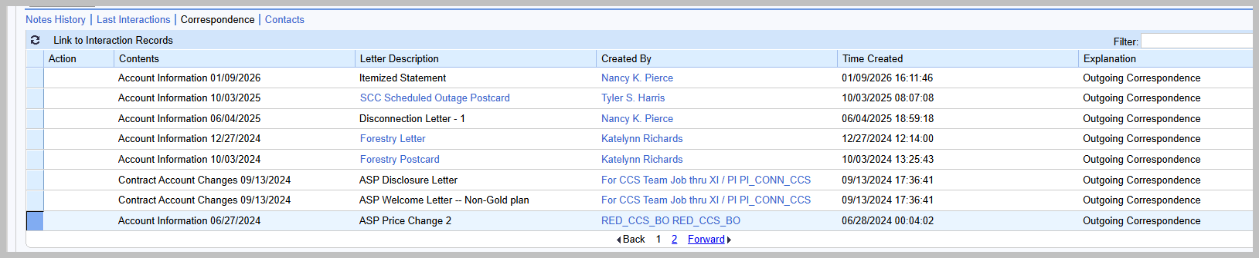

~~~~~~~~~~~~~~~~~~~~~~~~~~~~~~~~~~~~~~~~~~~~~~~~~~~~~~~~~~~~~~~~~~~~~~~~~~~~~

Kubra
More Mass comms
~~~~~~~~~~~~~~~~~~~~~~~~~~~~~~~~~~~~~~~~~~~~~~~~~~~~~~~~~~~~~~~~~~~~~~~~~~~~~

Power App Integration
Fraud Forms
Fraud tips not sending to forms menu
Goes to sharepoint
Action: Stephanie/Jennifer – how many of the Remove Fraud Block From we are receiving from SharePoint
May decide to remove

Potential Decision with Power App Interation
Option 1: Remove completely if not being used
Option 2: Convert to Case (SNAP docs providing URL in case)

Resend PIR Factsheet – is in ECC (triggering email with Link) (email is sent through SAP generated by Move In workflow) à email is the welcome letter with the FACTA link if needed (FACTA link expires after certain time)
Customer needs to provide information to get this service approved

Customers often call back for a new link

Resend PIR Facta Link – Custom UI Component

Keeping PIR Facta in Correspondence due to development behind it + referencing MIMO to it for test case purposes, Jose follow up with Dawn (link is kept with MIMO PDD, development is kept with Correspondence)

Add Sending PIR FACTA Link at end of Move In in Move in PDD Items
~~~~~~~~~~~~~~~~~~~~~~~~~~~~~~~~~~~~~~~~~~~~~~~~~~~~~~~~~~~~~~~~~~~~~~~~~~~~~
Genesys, Paymentus, Kubra, One time Payment, Energy Use Dashboard
Online Profile Management à OCTA
If the CSR is not in Octa, they won’t be able to load this
Decision to add Online Profile Management
Forgotten information
Keeping Octa for future state
Need this for CSRs forgetting information

Customer Preferences -> Kubra link, how we set up customer preferences
E-Bill Enrollment
Internal customer portal screen that feeds Kubra
Keeping Customer Preferences for future state
Some info that is in the internal customer portal screen is populated from ECC

CE Admin View à shows what customer web portal will look like so you see what the agent sees
The user admin feature is also used for the customer saying my online account says this is due on this date. Then I go in to look what they see. A lot of times they mistake the past due being due on the current bill due date.

In preferences, if the ability to search for a specific account/address is an option, and the ability to enroll multiple accounts at once would be absolutely amazing. The BC has business partners that have 100+ on one profile, and we have to enroll the accounts one at a time.

Chat feature is just a bot, doesn’t go to a live agent but will help guide the customer through the process.

Business center has chat option built into accounts coded 01- directs the chat to an agent

Agent chats with them live via Genesys, need to be logged into a business center profile online. This will give the customer a link directly to what the customer is inquiring about. Transfer over to agent to process

Previously was a big pain point not having this.

Agents find this very useful (business center uses this a lot too). The customer specific portal is very important

This call can go to anyone currently. Some CSRs don’t have personal accounts so they use the customer specific view

Keeping CE Admin View
We will need to keep this link because CSRs, Business Center need to use this. We will just figure out the best way to optimize this process un design

Dun and Bradstreet – CAN REMOVE! Business center is using this for analytics in the back end, Link to Hoovers is a fee based website where agents can go in and see all parent/ child relationships of a corporation à Dawn is checking the TCODE list to see how much this is used

Hallmark going away.
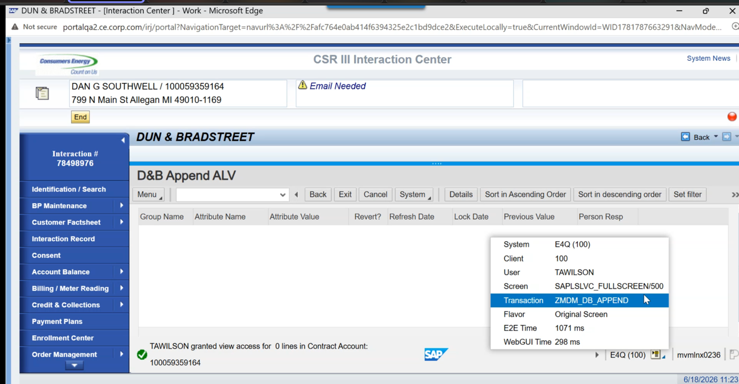
Energy Use Details.- used all the time, passing over 2 peices of data
2 different portals for energy use, drives to GridX
Data in GridX coming from SAP
But the information in the hyperlink is oulling from the contract account

Go down to the detail by the hour
This is used for High Bill inquiries

Admin tool wasn’t sufficient – so we created this view
When someone calls in about a high bill, they have the information to back the reason why this spiked.

Jose Demoing Consumption Analysis board in next session
Want a demo of Grid X – finding appropriate places in Service Cloud

Potentially will remove GridX from future state
If we don’t need Grid X in Service Cloud, it’s okay because the Energy Use Details program maintained by GridX is customer facing

Use GridX for rate comparisons

Paymentus
Carrying over account number and Zipcode
This is where you confirm if the customer made a payment but hasn’t hit the system yet, this feeds into system real time. Paymentus maintains declinnig of cards, bank details won’t show in SAP

Integration with Paymentus- nothing should change
If we are adding/consolidating business roles, we need to let paymentus know how to map the roles to the right dashboard.
Paymentus has a mapping table
Role names / consolidations are changing à so regardless we will have to tell paymentus that this exercise is happening

Streetlight Outage Map
Check status of order and create Streetlight orders

Electra OMS
Back up order system
Different profiles based on the job
Can look up info here you can’t see in CRM
Can put interaction number, account number
Get more history on acccount details
If Service Cloud is down, we won’t be able to get to this

Business Center uses this almost daily for on call agents to get out
Updated Crew notes that are not in order management
Any outage or storm question they automatically go here since there is significantly more info
Where will we store the other links in Service Cloud V2?
We will have the CSRs go to the iconnect page for when Service Cloud is down

Mohanta exploring simplified URLs that don’t require any parameters being passed. Mohanta identify and see which we can just add via basic link through Service Cloud – minimize WRICEF and only focus on ones requiring
Paymentus, Dashboard, Preferences

Xmatters sending alerts to phones à ensure someone is testing this (non Service Cloud)
Action Items |  |  |  | Person Responsible | Deadline
Tarah identifying what is critical fields for the Factsheet (Meeting on 6/19 with CSRs to get critical fields) |  |  |  | Tarah
Need to determine who is actually using these old Archived Docs  (Dawn brought up an example of an account that had been moved in 20 years prior, but was only showing 2 years of history – we need to look into this) |  |  |  | Dawn
Tarah get list of types of documentation used for the ISIS integration  Z Letter- upload letters, postcards, emails forms, save as PDF – seen in Correspondence tab and records (only specific ones- Planned outage, scheduled work – 9 total) – get full list from Tarah or Ajay |  |  |  | Tarah
Is standard service for correspondence is enough for Service Cloud? Need to determine if this is custom (Decision from Mohanta and Jose)  Things that don’t go through ISIS are still shown through that Correspondence tab,  Table that shows hyperlinks /not for the letters (Data is filled from ECC Via RFC, create Hyperlink to ISIS)  Bill PDFs (link directly from ECC from ISIS) |  |  |  | Jose and Mohanta
Power App Integration  How many of the Remove Fraud Block From we are receiving from SharePoint  (May decide to remove if it’s not a lot) |  |  |  | Stephanie/Jennifer
Jose Demoing Consumption Analysis board in next session |  |  |  | Jose
Want a demo of Grid X – need finding appropriate places in Service Cloud |  |  |  | Stephanie?
Mohanta exploring simplified URLs that don’t require any parameters being passed. Mohanta identify and see which we can just add via basic link through Service Cloud – minimize WRICEF and only focus on ones required |  |  |  | Jose and Mohanta

